
Medicinal Herbs Identification System
Using Deep Learning for Leaf Image Classification
Project Report
Submitted by:
Sumanth G
Roll Number / Employee ID: To be filled
Department: Tech Team
Institution/Organization: DataLegos

Submitted to:
Name: To be filled
Designation: To be filled
Department: To be filled
Date of Submission: 5th June 2025
Location: Nellore

Low-Level Design (LLD)

Overview of the Module/System
Brief Description
The Medicinal Herbs Identification System is a web-based application that enables users to upload images of herb leaves and obtain the herb name along with descriptive information about its medicinal properties.

Purpose and Functionality
- Identify the class of a medicinal herb based on a leaf image using a ResNet50 deep learning model.
- Retrieve detailed herb information using the Gemini API (Generative AI).
- Provide an intuitive interface via Streamlit for users to interact with the system.

Architectural Components

System Diagram:

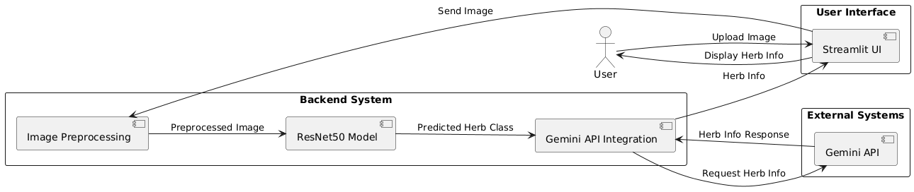

User → Streamlit UI → Image Preprocessing → ResNet50 Model → Herb Class → Gemini API →
Herb Info → Streamlit UI → User

Class Diagram:

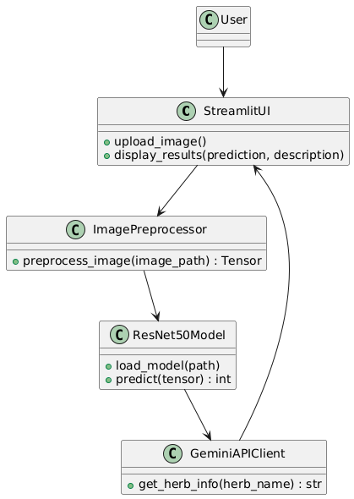

Sequence Diagram:

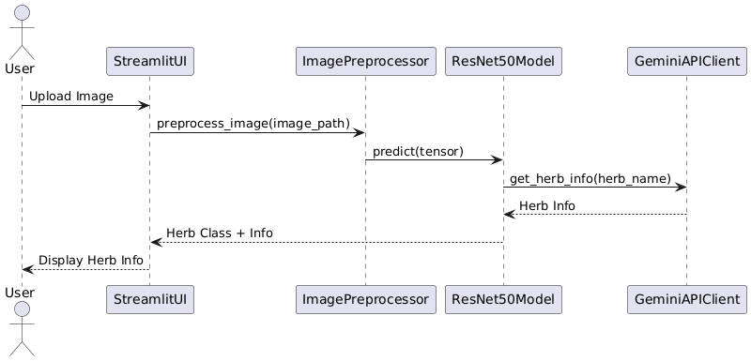

Modules & Submodules:

Module | Submodules / Functions
Streamlit UI | upload_image(), display_results()
Image Preprocessing | preprocess_image()
ResNet50 Model | load_model(), predict()
Gemini API Client | get_herb_info()

Data Structures & Storage
Tables & Schemas (Future Enhancement)
User Table (optional future): Store uploaded image info & user history.
Field | Type
user_id | INT (PK)
image_path | VARCHAR
prediction | VARCHAR
timestamp | TIMESTAMP

In-memory Structures
- Dictionary: Class index → Herb Name (loaded from classes.txt).
- Tensor: PyTorch Tensor used for image data.
- String: Herb description from Gemini API.

API & Interface Specifications

Function Definitions
- # Streamlit UI
def upload_image() -> Image
def display_results(prediction: str, description: str) -> None

- # Image Preprocessing
def preprocess_image(image_path: str) -> torch.Tensor

- # ResNet50 Model
def load_model(path: str) -> nn.Module
def predict(model: nn.Module, tensor: torch.Tensor) -> int

- # Gemini API Client
def get_herb_info(herb_name: str) -> str

External Dependencies
- PyTorch (torch, torchvision)
- Streamlit
- Gemini API SDK or HTTP requests
- PIL (Pillow) for image handling

Business Logic & Algorithms

Core Logic
- User uploads an image.
- Image is preprocessed: resize to 224x224, normalized.
- Image tensor is fed into the ResNet50 model.
- The model outputs a class index.
- The class index is mapped to a herb name.
- Gemini API is queried with this herb name.
- Gemini API returns a formatted herb description.
- The result is displayed to the user via Streamlit.
Edge Cases & Exception Handling
- Invalid image format → Show error.
- Model load failure → Fallback message.
- Gemini API error/timeout → Retry, fallback message.

Error Handling & Debugging
Managed Errors
- File upload validation (image format check).
- Try/except around model prediction.
- API call retries & fallback in case of timeout.
Logging
- Errors and exceptions logged to error.log with timestamps.
Recovery Mechanisms
- Graceful fallback to "Herb info currently unavailable" message.
- Inform the user of any known issues in UI.

Security Considerations
- API Key for Gemini stored in environment variables, not in code.
- No user authentication required (public app), but can be added.
- No personally identifiable user data stored.
- Secure HTTPS endpoint for Gemini API.

Performance Optimization
- Image preprocessing optimized for GPU batch processing (if needed).
- Model loaded once at startup — no reloading per request.
- Gemini API response cached (simple LRU cache can be added).
- Streamlit UI lightweight & asynchronous updates where possible.

Testing & Validation Approach
Unit Tests
- Image preprocessing pipeline tested with mock images.
- Model prediction tested with test images + known expected classes.
- Gemini API client tested with unittest.mock to simulate API responses.

Performance Benchmarks
- Target: <2 seconds for full request → response cycle.
- Model inference time: <500 ms on CPU.

Assumptions & Constraints
Assumptions
- User will upload clear leaf images with sufficient quality.
- The ResNet50 model is trained & fine-tuned with good accuracy.
- Gemini API will return meaningful herb info based on prompt.
Constraints
- Dependency on GroqAPI uptime and availability.
- Current model limited to 27 predefined herb classes.
- Not a general plant identifier (focused on medicinal herbs).

Conclusion
This LLD describes the detailed architecture, flow, components, and considerations for the Medicinal Herbs Identification System. The design ensures modularity, scalability, and extensibility, making it suitable for enhancements like offline support, user accounts, and improved herb database in the future.

Deliverables
- LLD document.
- Module specifications and scripts.

Glossary – Low-Level Design Document
Term | Definition
LLD (Low-Level Design) | A detailed design phase that specifies the internal logic, functions, data structures, and implementation of each system module.
Streamlit | A Python-based web framework used for building interactive web applications for data science and machine learning use cases.
upload_image() | A function that allows users to upload an image file through the Streamlit interface.
display_results() | A function that displays the predicted herb class and detailed information returned from the Gemini API.
preprocess_image() | A function that resizes, normalizes, and converts a user-uploaded image into a PyTorch tensor suitable for model input.
load_model() | A function to load the pre-trained ResNet50 model from a .pth file.
predict() | A function that takes the model and image tensor, performs inference, and returns the predicted class index.
get_herb_info() | A function that queries the Gemini API using a herb name and retrieves a text description of its medicinal uses.
ResNet50 | A 50-layer convolutional neural network used for image classification tasks. In this system, it classifies leaf images of medicinal herbs.
Torch / PyTorch | A popular deep learning framework used for model training, inference, and tensor manipulation.
Torchvision | A PyTorch library that provides access to pre-trained models and tools for image processing.
PIL (Pillow) | A Python library used for image manipulation, including reading, resizing, and converting image formats.
Tensor | A multi-dimensional array used in PyTorch to represent input data (images) and model outputs.
classes.txt | A file mapping class indices (0–26) to herb names. It ensures consistent label interpretation across preprocessing and prediction phases.
Gemini API | A language model API used to generate herb descriptions based on the predicted herb name (acts as the generative component).
Environment Variables | Secure variables used to store sensitive credentials (like API keys) outside the main application codebase.
LRU Cache | A memory-based Least Recently Used cache that stores recent API results to reduce redundant calls and improve response time.
Model Inference | The process of making predictions using a trained machine learning model on new/unseen data.
Edge Case | Unusual or extreme inputs that may break or degrade the system if not properly handled (e.g., blurry images or wrong file types).
Fallback Message | A default message shown to users when something fails (e.g., API timeout, model load error).
Sequence Diagram | A UML diagram that shows the step-by-step interaction between system components during a single workflow (e.g., image → herb info).
Class Diagram | A visual representation of system classes (modules) and their relationships, often used in object-oriented design.
System Diagram | A high-level diagram showing how various system components (UI, model, API, etc.) interact to fulfill a user request.
Validation Set | A subset of the dataset used during training to fine-tune model parameters and avoid overfitting.
Unit Testing | Testing individual components or functions of the code in isolation to ensure correctness.
unittest.mock | A Python module used to create mock objects for testing external APIs or functions without actually invoking them.
HTTPS | A secure protocol for data transfer on the web, ensuring encryption of data sent between the app and Gemini API.
Asynchronous Updates | UI updates that don’t block the main thread, improving responsiveness during tasks like image processing or API calls.
GPU Batch Processing | Running model predictions on a batch of inputs using a GPU, for faster performance compared to CPU inference.
Timestamp | A record of the exact date and time when an event occurred (e.g., prediction made). Useful for logging and user history.
VARCHAR | A variable-length character data type used in database schemas to store text such as file paths or class names.
PK (Primary Key) | A unique identifier for each row in a database table, ensuring no duplicate entries (e.g., USER_ID in user table).
Error Logging | Recording errors and exceptions (with timestamps) to a log file for future debugging and audit trails.
Constraint | A limitation or restriction placed on system functionality (e.g., limited number of herb classes).
Assumption | A condition expected to be true during system operation (e.g., users upload valid image formats).

Reviewed By:
Naveen Gunapaneni

